

MATLAB EXPERIMENT 1B

Maxima and Minima of a function of one variable



February 12, 2021

BIMAL PARAJULI

20BDS0405

Department of Mathematics

School of Advanced Sciences

MAT 1011 – Calculus for Engineers (MATLAB)

Experiment 1-B

Maxima and Minima of a function of one variable

Prepared by: Bimal parajuli

Registration Number: 20BDS0405

**Question 1:**

**Find the local and global maxima and minima for the function $x^{3}-12x-5$ on x∈(−4,4).**

**Code:**

clear

clc

close all

syms x

%the given function and interval

f(x)= x^3-12*x-5;

I=[-4,4];

f1(x)=-f(x);

%End values of the interval

a=I(1);b=I(2);

t=linspace(a,b,100); %create 100 points in between a and b (in the interval)

g=double(f(t)); %Finding the values of f(x) at t values

[lmax_f,loc]=findpeaks(g);

lmax_x=round(t(loc),4);

h=double(f1(t));

[lmin_f,loc]=findpeaks(h);

lmin_x=round(t(loc),4);

disp('Local maximum occur at x=')

disp(lmax_x)

disp('The Local Maximum value(s) of the function are ')

disp(double(f(lmax_x)))

disp('Local minimum occur at x=')

disp(lmin_x)

disp('The Local Minimum value(s) of the function are ')

disp(double(f(lmin_x)))

%Plotting the function

plot(t,f(t));

hold on;

%Pointing the local maxima on the curve of f(x)

plot(lmax_x,double(f(lmax_x)),'or');

%Pointing the local minima on the curve of f(x)

plot(lmin_x,double(f(lmin_x)),'*g');

hold off

**OUTPUT:**

Local maximum occur at x=  
 -1.9798  
  
The Local Maximum value(s) of the function are   
 10.9976  
  
Local minimum occur at x=  
 1.9798  
  
The Local Minimum value(s) of the function are   
 -20.9976

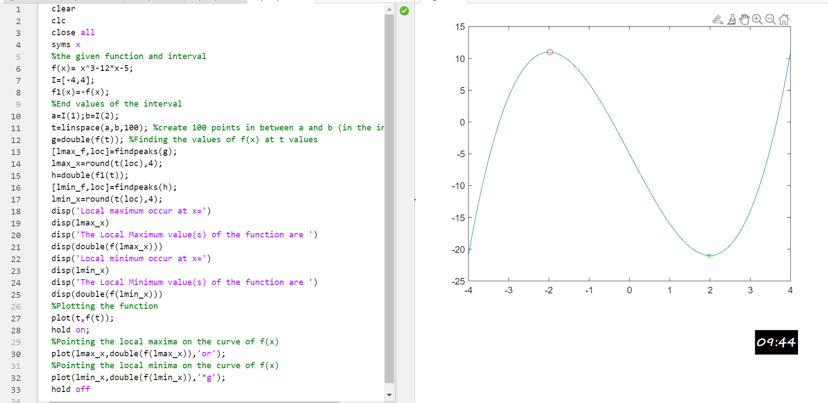

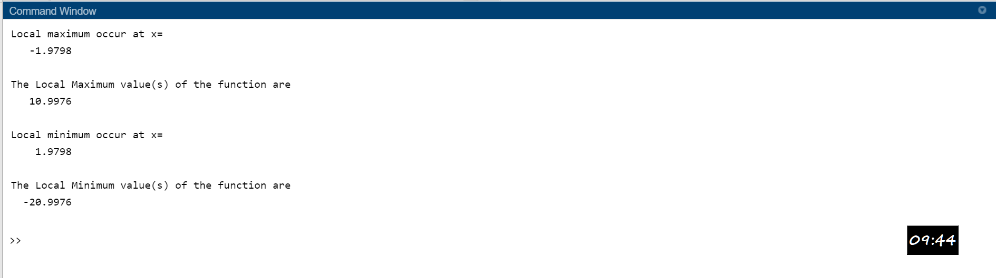

**QUESTION 2:**

**Find the local and global maxima and minima for the function x +sin 2x on x∈(−5,5).**

**CODE:**

clear

clc

close all

syms x

%the given function and interval

f(x)= x+ sin(2*x);

I=[-5,5];

f1(x)=-f(x);

%End values of the interval

a=I(1);b=I(2);

t=linspace(a,b,100); %create 100 points in between a and b (in the interval)

g=double(f(t)); %Finding the values of f(x) at t values

[lmax_f,loc]=findpeaks(g);

lmax_x=round(t(loc),4);

h=double(f1(t));

[lmin_f,loc]=findpeaks(h);

lmin_x=round(t(loc),4);

disp('Local maximum occur at x=')

disp(lmax_x)

disp('The Local Maximum value(s) of the function are ')

disp(double(f(lmax_x)))

disp('Local minimum occur at x=')

disp(lmin_x)

disp('The Local Minimum value(s) of the function are ')

disp(double(f(lmin_x)))

%Plotting the function

plot(t,f(t));

hold on;

%Pointing the local maxima on the curve of f(x)

plot(lmax_x,double(f(lmax_x)),'or');

%Pointing the local minima on the curve of f(x)

plot(lmin_x,double(f(lmin_x)),'*g');

hold off

**OUTPUT:**

Local maximum occur at x=  
 Column 1  
 -2.0707  
 Column 2  
 1.0606  
 Column 3  
 4.1919

The Local Maximum value(s) of the function are   
 Column 1  
 -1.2293  
 Column 2  
 1.9129  
 Column 3  
 5.0548

Local minimum occur at x=  
 Column 1  
 -4.1919  
 Column 2  
 -1.0606  
 Column 3  
 2.0707

The Local Minimum value(s) of the function are   
 Column   
 -5.0548  
 Column 2  
 -1.9129  
 Column 3  
 1.2293

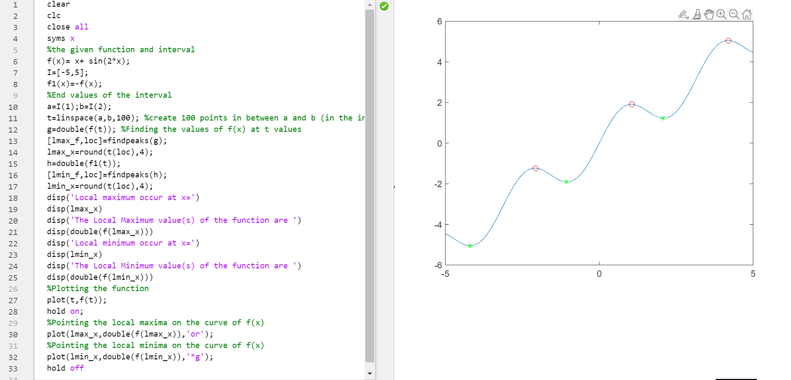

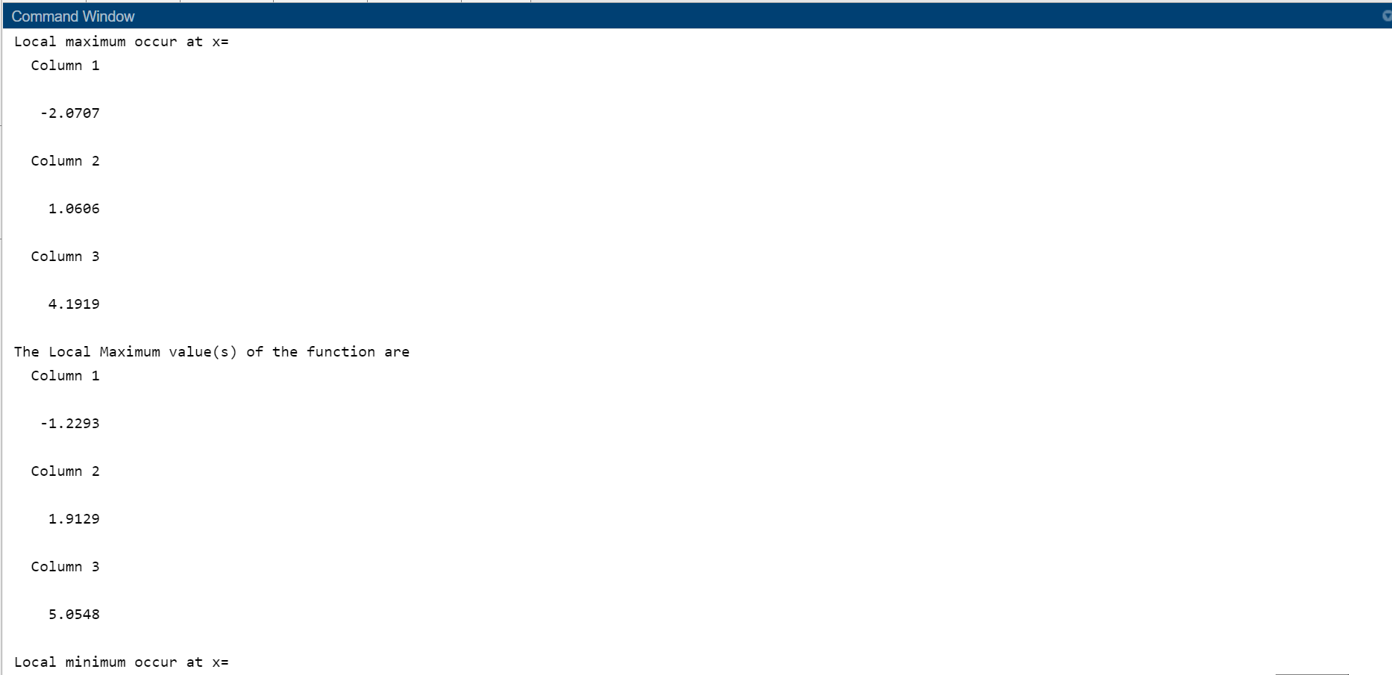

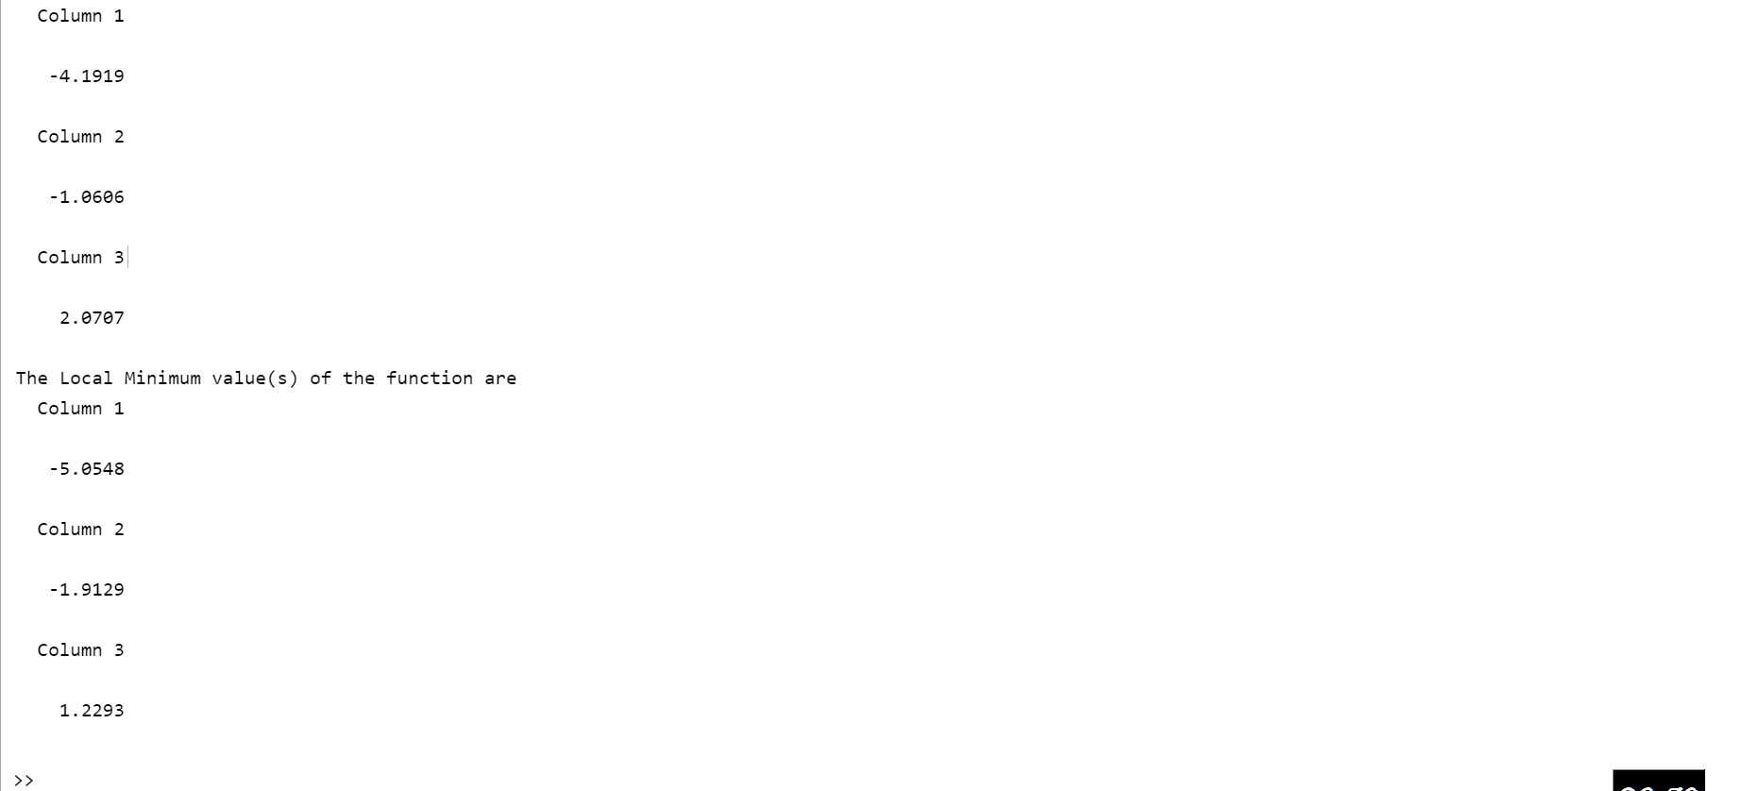

*--THE END--*

Page intentionally left blank

Page intentionally left blank